University of the West of Scotland
School of Computing, Engineering and Physical Sciences

MEng/MSc Cyber Security Project Specification

Student name: Pratik Paudel
Banner ID: B01829081
Email: b01829081@studentmail.uws.ac.uk
Project being undertaken on part-time or full-time basis: Full Time
MEng/MSc Programme/stream: MSc Advanced Computer Security (Cybersecurity)
MEng/MSc Programme Leader: Althaff Irfan Cader Mohideen

Project Title:
Investigating the Impact of Class Imbalance Treatment Techniques on Machine Learning-Based Phishing Website Detection.

Research Question to be answered:
How do different class imbalance treatment techniques affect the performance of machine learning models for phishing website detection?

Outline (overview) and overall aim of project:

Phishing websites are still considered as one of the most prevalent and persistent threats in cybersecurity due to their ability to steal credentials, deliver malware and enable fraud at a large scale. With the rapid advancement of Artificial Intelligence (AI) and Machine Learning (ML), these technologies have demonstrated significant success across various domains, including healthcare, finance, retail, and transportation. In these areas, AI/ML techniques are widely used to identify patterns, automate decision-making, and improve prediction accuracy. As a result, they have been increasingly adopted in cybersecurity, where AI/ML techniques being widely used in various threat detection, intrusion detection, spam filtering as well as phishing detection applications.

In particular, phishing detection has seen significant promise with AI/ML solutions due to their ability to process wide range of data and detect patterns and characteristics within the URLs and website elements that are faster and more adaptable than relying on the rules. However, despite these promising results, AI/ML-based phishing detection approaches still face several important limitations. One challenge in machine learning phishing detection is the class imbalance problem, in which legitimate URLs are much more plentiful than phishing URLs. It is important because the results can be misleading in these environments as the model may appear effective overall but still miss or fail to identify phishing cases. Consequently, addressing class imbalance is essential for developing reliable phishing detection systems.

There are several previous works that focused on comparisons of classifiers for phishing detection, but there is limited research investigating the impact of various class imbalance treatment techniques across different datasets and feature spaces. In particular, there is a lack of studies examining how different class balancing strategies influence the performance of machine learning models under varying feature representations for phishing website detection.

Therefore, the overall aim of this project is to investigate the impact of class imbalance treatment techniques on the performance of various machine learning models for phishing website detection. Specifically, in this study, we will use the UCI Phishing Websites dataset and the Hannousse and Yahiouche 87-feature benchmark dataset to compare the effectiveness of different class balancing strategies under various feature settings.

Objectives (list of tasks to be undertaken to achieve overall aim of the project and to answer the research question posed):
- Conduct a structured literature review on phishing detection, class imbalance as well as imbalance-aware evaluation.
- Identification and analysis imbalance treatment techniques such as no resampling, SMOTE, under sampling, and class weighting.
- Acquisition and preprocessing of the UCI Phishing Websites dataset and the Hannousse and Yahiouche benchmark dataset.
- Train selected machine learning classifiers using the same preprocessing pipeline across both datasets and class imbalance treatment techniques.
- To evaluate the trained model's performance under different class imbalance treatment techniques through appropriate evaluation metrics
- To analyse which class imbalance treatment approach performs best for phishing detection and discuss the implications, and discuss the implication and findings

Work Plan
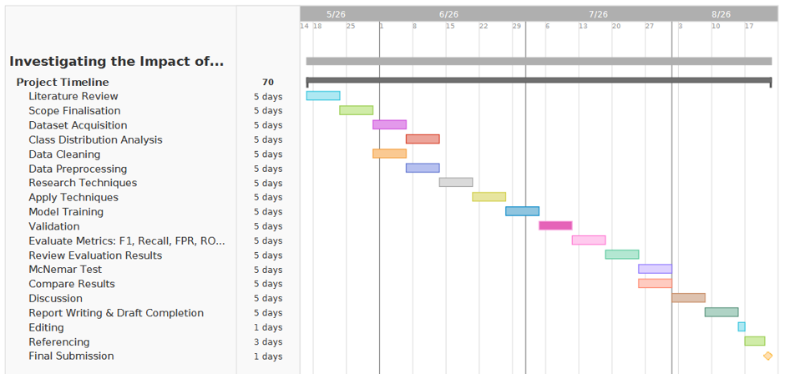

CyBOK Knowledge Areas (Please check at least two relevant areas your project going to be covered):

Human, Organisational & Regulatory Aspects | ☐ | Risk Management & Governance
 | ☐ | Law & Regulation
 | ☐ | Human Factors
 | ☒ | Privacy & Online Rights
Attacks & Defences | ☒ | Malware & Attack Technologies
 | ☒ | Adversarial Behaviours
 | ☐ | Security Operations & Incident Management
 | ☐ | Forensics
Systems Security | ☐ | Cryptography
 | ☐ | Operating Systems & Virtualisation Security
 | ☐ | Distributed Systems Security
 | ☒ | Formal Methods for Security
 | ☐ | Authentication, Authorisation & Accountability
Software and Platform Security | ☒ | Software Security
 | ☒ | Web & Mobile Security
 | ☐ | Secure Software Lifecycle
Infrastructure Security | ☐ | Applied Cryptography
 | ☐ | Network Security
 | ☐ | Hardware Security
 | ☐ | Cyber Physical Systems
 | ☐ | Physical Layer and Telecommunications Security

Indicative reading list (references to be correctly presented) and resources:
Hannousse, A. and Yahiouche, S. (2021). Towards benchmark datasets for machine learning based website phishing detection: An experimental study. Engineering Applications of Artificial Intelligence, [online] 104, p.104347. https://doi:10.1016/j.engappai.2021.104347.

Kocyigit, E., Korkmaz, M., Sahingoz, O.K. and Diri, B. (2024). Enhanced Feature Selection Using Genetic Algorithm for Machine-Learning-Based Phishing URL Detection. Applied Sciences, [online] 14(14), p.6081. https://doi:10.3390/app14146081.
‌
Mousa, A.A., Hassan, S.A.-D.H., Rashid, M.K. and Al-Saady, M. (2025). Safeguarding Patient Data: Machine Learning for Phishing URL Detection in Healthcare Systems. Journal of Advanced Research Design, [online] 131(1), pp.47–60. https://doi:10.37934/ard.131.1.4760.
‌
Salah, Z., Abu Owida, H., Abu Elsoud, E., Alhenawi, E., Abuowaida, S. and Alshdaifat, N. (2024). An Effective Ensemble Approach for Preventing and Detecting Phishing Attacks in Textual Form. Future Internet, [online] 16(11), p.414. https://doi:10.3390/fi16110414.
‌
Sutter, T., Bozkir, A.S., Gehring, B. and Berlich, P. (2022). Avoiding the Hook: Influential Factors of Phishing Awareness Training on Click-Rates and a Data-Driven Approach to Predict Email Difficulty Perception. IEEE Access, [online] 10, pp.100540–100565. https://doi:10.1109/access.2022.3207272.
‌
Tan Kian Hua and Macgregor, A. (2022). An Efficient Phishing Website Detection Plugin Service for Existing Web Browsers Using Random Forest Classifier. Authorea (Authorea). https://doi:10.22541/au.166792122.20565582/v1.

Ul Hassan, I., Ali, R.H., Ul Abideen, Z., Khan, T.A. and Kouatly, R. (2022). Significance of Machine Learning for Detection of Malicious Websites on an Unbalanced Dataset. Digital, [online] 2(4), pp.501–519. https://doi:10.3390/digital2040027.

Marking scheme:
Introduction 5%
Literature Review 15%
Research Design and Methodology 10%
Design and Implementation 20%
Testing 10%
Results and Analysis 10%
Conclusions and Recommendations 10%
Critical Self Evaluation 10%
Structure, Style and References 10 %

Supervisor:
Aboua Ange Kevin N'Da

Moderator:
Raman Singh

Programme Leader:
Althaff Irfan Cader Mohideen

Date specification submitted:
24/06/2026

Please complete the ‘ethics’ form below for all projects.

School of Computing, Engineering and Physical Sciences
MSc PROJECT – REQUIREMENT FOR ETHICAL APPROVAL

SECTION 1: TO BE COMPLETED BY THE STUDENT

Please answer the following questions: | Select Yes or No
Does your project involve: human subjects (e.g. as clients, providers of requirements, ‘testers’/users), access to unpublished company documents/records, private personal data, questionnaires, surveys, focus groups and/or other interview techniques? | No
If your answer above is Yes, have you discussed with your supervisor and applied for ethical approval using the university’s Ethical Review Manager online system? | Choose an item.
If you haven’t applied for the ethical approval, have you started preparing necessary documents required for the ethical approval, e.g. information sheet, consent form, questionnaires, etc? | Choose an item.
I confirm that I will not start the above mentioned project work before obtaining formal ethical approval. | Choose an item.

If answering yes to the first question above, and if you have not done so already, please prepare and submit an application for ethical approval through the university’s “Ethical Review Manager” (ERM) system, which is available at https://uws.forms.ethicalreviewmanager.com.

Before doing so, please consult the ERM applicant user guide, which can be downloaded from: https://www.uws.ac.uk/media/5364/erm-applicant-user-guide.pdf
The process for making applications and the principles applied in the School of CEPS are contained within the Ethical Approval Process. Please read this document before making an application for ethical approval.
Please provide any additional information, comments and suggestions:

Name of Student (Print name): Pratik Paudel

Signature: Pratik Paudel
Date: 12/06/2026

SECTION 2: TO BE COMPLETED BY THE PROJECT SUPERVISOR
I understand that the above project does not require ethical approval (*please delete as appropriate).

Supervisor (print name): Aboua Ange Kevin N’DA

Signature: Aboua Ange Kevin N’DA

Date: 24/06/2026

IMPORTANT: please note that by signing this form all signatories are confirming that any potential ethical issues have been considered and, where necessary, an application for ethical approval has been/will be made via the Ethical Review Manager software.
Any project requiring ethical approval, but which has not been given approval will not be accepted for marking.

Ethical approval cannot be sought in retrospect.

